Exercise 1: Mocking and Stubbing
Scenario:
You need to test a service that depends on an external API. Use Mockito to mock the external API and stub its methods.

Pom.xml:
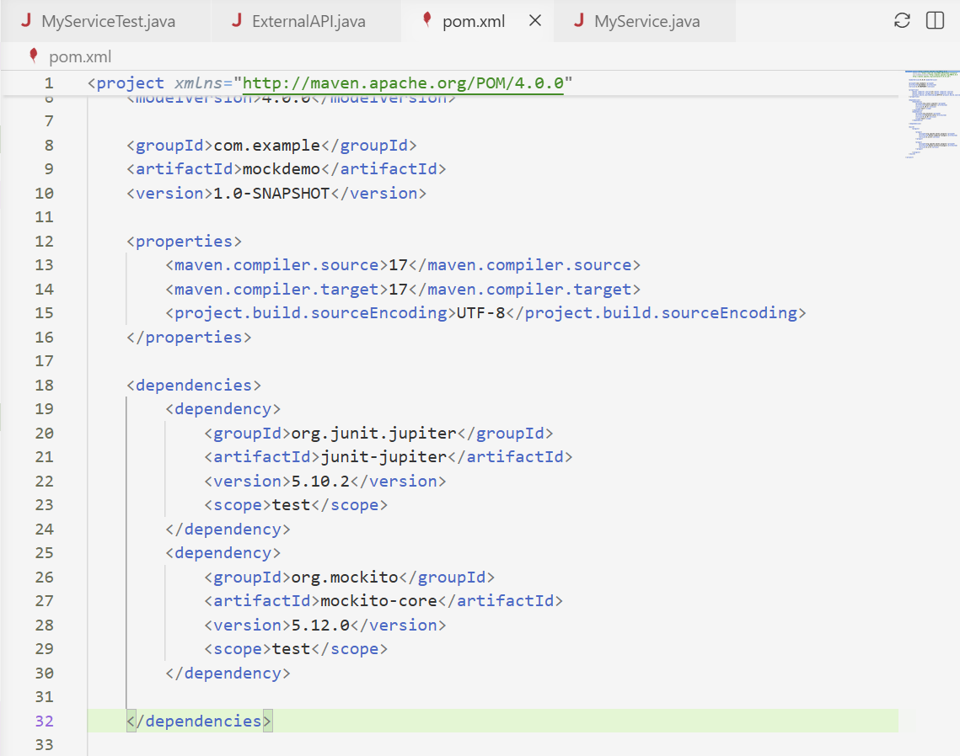
External API
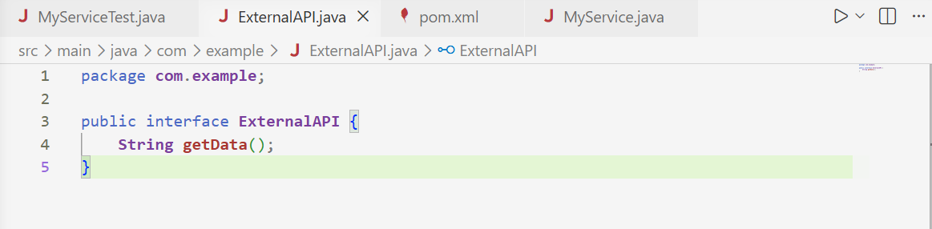

MyService.java:
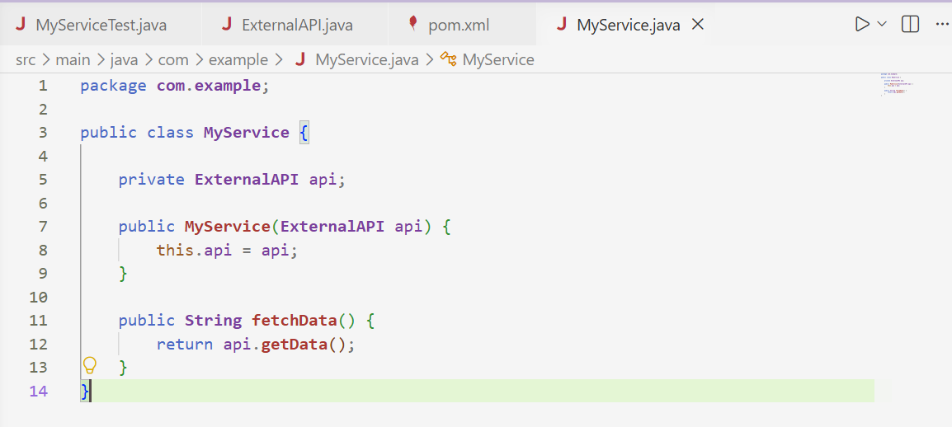

MyServiceTest.java:
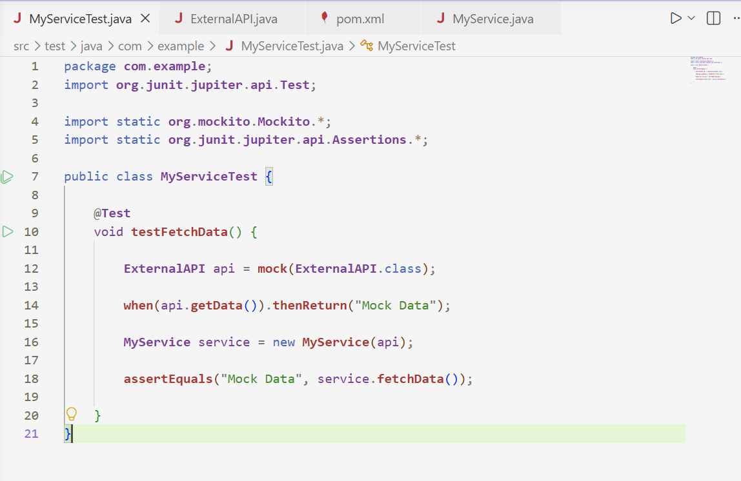

Output:
